# The follow was used for this guide.

## apache-cxf-2.3.0

http://cxf.apache.org/download.html

eclipse-jee-galileo-win32.zip

http://www.eclipse.org/downloads/

JRE6

http://www.java.com/en/download/inc/windows_upgrade_xpi.jsp

|  |
| --- |
| Option 1 : JaxB binding file with CXF You’ll need the following binding files, wsdl and xsd contained in the WS directory  **cmdLine (Administrator) - From C:\Download\Java\Apache CXF\apache-cxf-2.3.1\bin**  wsdl2java.bat -d Txn -b WS/JaxbBindingsTxn.xml -validate -verbose -autoNameResolution -client WS/CwsTransactionProcessing.wsdl  wsdl2java.bat -d Svc -b WS/JaxbBindingsSvcInfo.xml -validate -verbose -autoNameResolution -client WS/CWSServiceInformation.wsdl  wsdl2java.bat -d Tms -b WS/JaxbBindingsTms.xml -validate -verbose -autoNameResolution -client WS/CWSTransactionManagement.wsdl  wsdl2java.bat -d Billing -b WS/JaxbBindingsBilling.xml -validate -verbose -autoNameResolution -client WS/CWSDataServicesBilling.wsdl |

## Run the command lines above and you should have something like the following.

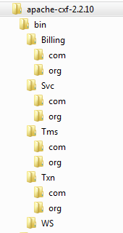

## Now launch Eclipse and select a workspace and create a new Project

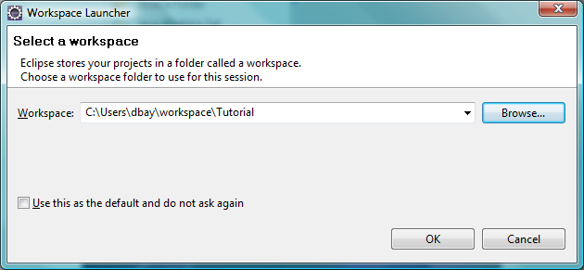

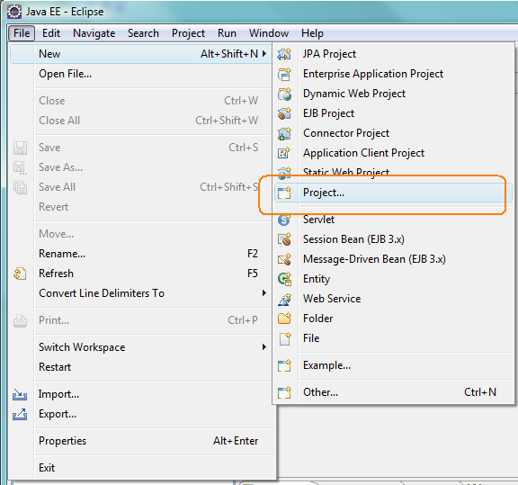

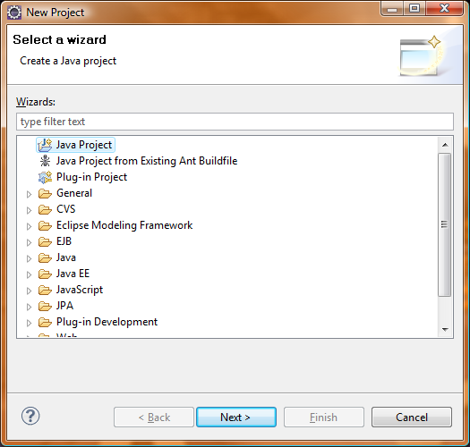

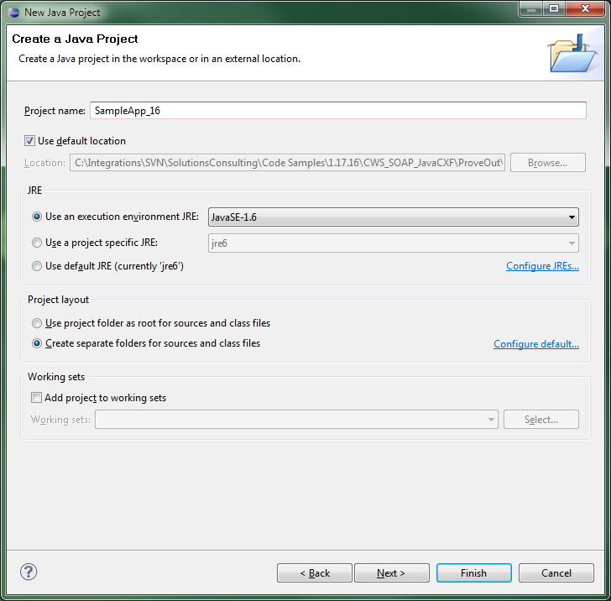

## Now import the proxy generated above from the file syste into the src folder. Make sure you get the ServiceInfo, Txn as well as the TMS

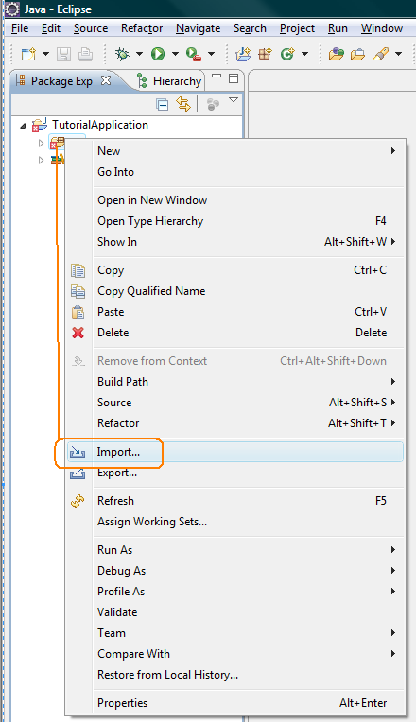

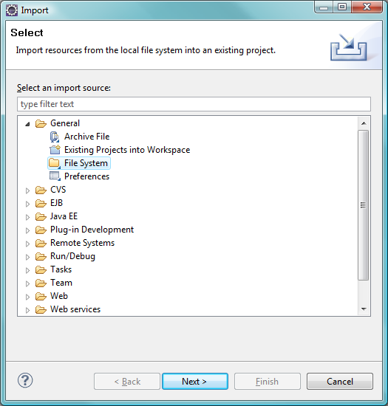

Make sure you import all three  
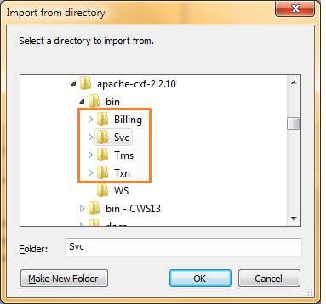

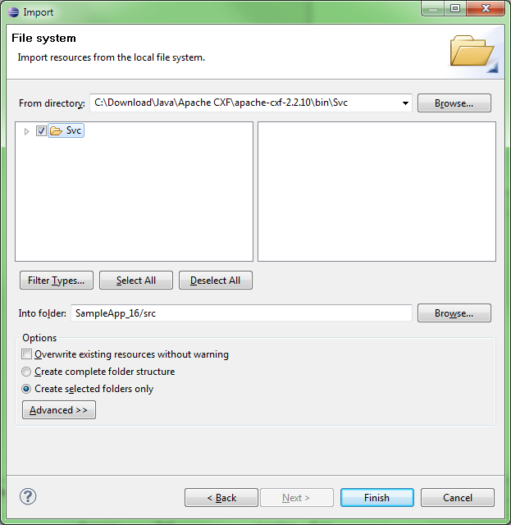

## Now add the necessary librairies

Import the Axis 2 libraries. I selected all of the default libraries however you should review each to make sure they are appropriate. I believe the only necessary library is “cxf-manifest.jar”

From top menu, Project->Properties, then Java Build Path->Libraries->Add

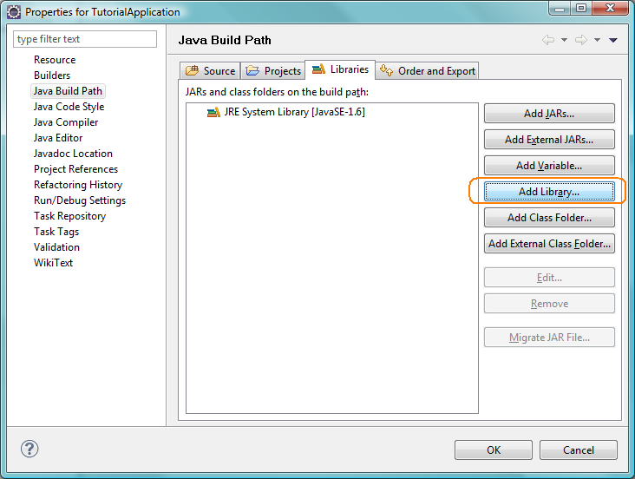

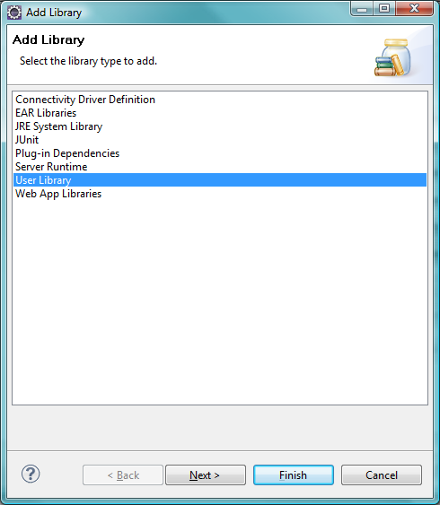

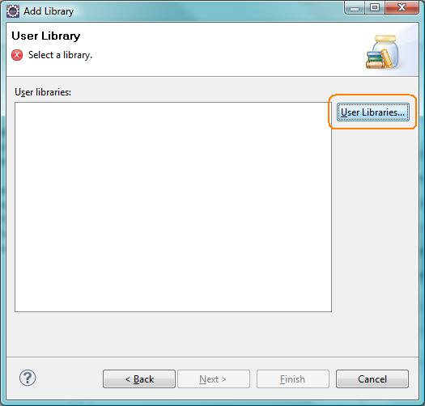

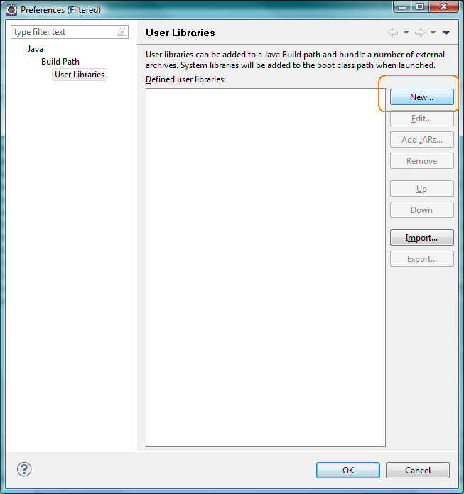

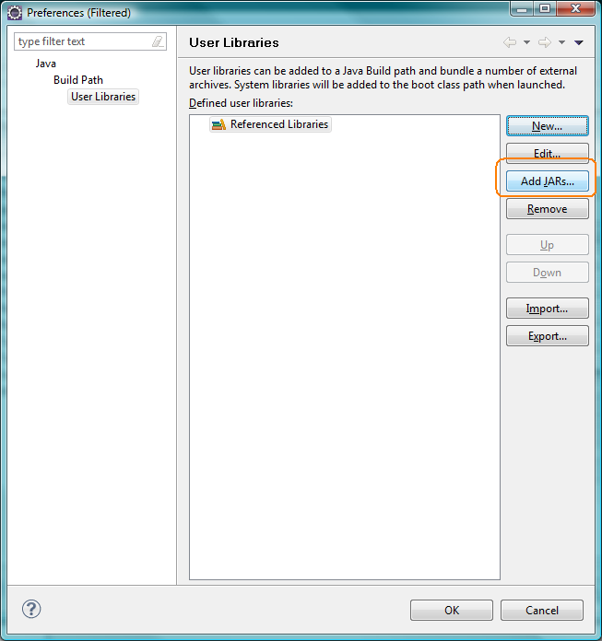

I simply selected all of the defaults that came with Apache CXF

NOTE : The only required library is cxf-manifest.jar

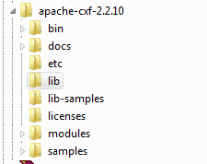

## Now let’s test it out

To test, let’s add two classes.

All of the files can be found in

“SampleApplication\”

1. main.java
2. SampleApplication.java
3. ConfigurationValues.java

First let’s add a new package I named mine SampleApplication

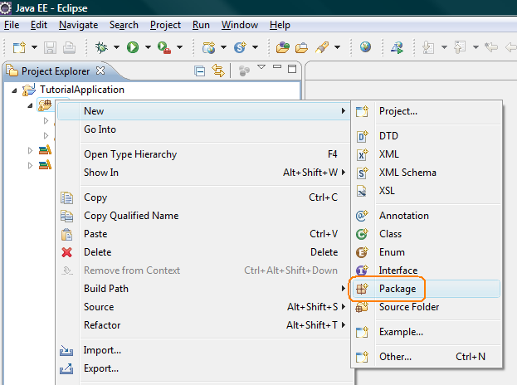

To that package lets add the classes above.

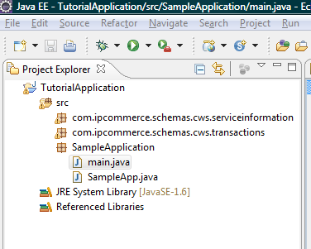

Paste the following in your class leaving the “package” declaration

## Sample Application

Import the classes from the Sample Application directory.